Name: Trung Kien Nguyen
Student ID: 104053642
7.1.1 Click on any visible memory word and type in 101 (followed by the "Enter" key). What value is displayed ? Why ?
0x00000065 (When we enter 101, the program understand it is in decimal, and because it’s in hex display mode, so it shows 65. (101 in dec means 65 in hex)
7.1.2 Click on another memory word, enter 0x101. What value is displayed, and why?
0x00000101 (When we enter 0x101, the program understand it is in hex, so it shows the value normally.
7.1.3 On another memory word, enter 0b101. What value is displayed, and why?
0x00000005 (When we enter 0b101, the program understand it is in binary, and because it’s in hex display mode, so it shows 5. (101 in binary means 5 in hex)
7.1.4 Does changing the representation of the data in memory also change the representation of the row and column-headers (the white digits on a blue background)? Should it ?
Yes, when we turn the display mode from hex to decimal or binary, the displaying values will change respectively.
7.2.1 Notice these column header memory address offsets go up in multiples of 0x4. Why is this ?
Because each memory word contain 32 bits, so the row-header value of each column should increase by 4 compared with the one before (4 bytes)
7.3.1 Take a screen shot of the simulator in full and add it to your submission document
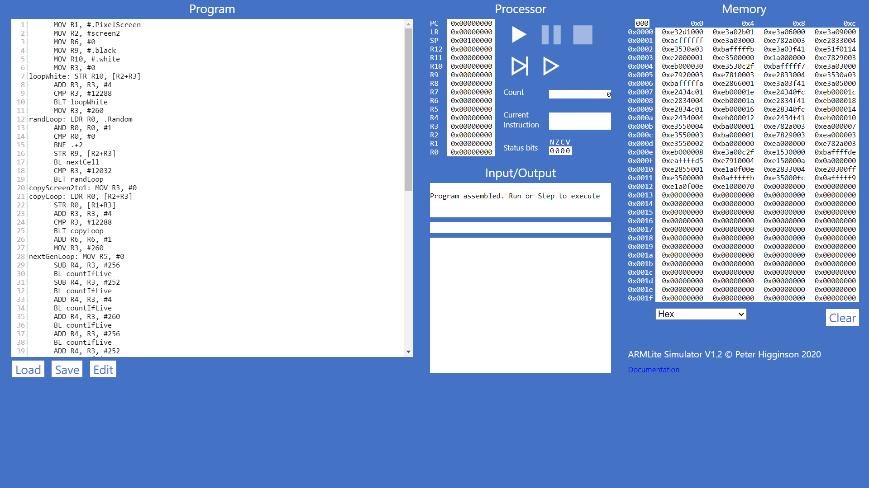
7.3.2
7.3.3
7.4.1
7.4.2 What do you think happens when you click the button circled in red ?
That button in the red circle is to run the processor only single steps
7.4.3 Has the processor paused just before, or just after executing the line with the breakpoint?
I think the processor paused just before the breakpoint
7.5.1 Before executing this instruction, describe in words what you think this instruction is going to do, and what values you expect to see in R0 and R1 when it is complete ?
MOV R0,#1 | To set the value in R0 by 1
ADD R1,R0,#8 | To add R0 value and 8, assign the result to R1
ADD R2,R1,#100 | To add R1 value and 100, assign the result to R2
SUB R3,R2,#25 | To subtract R2 value for 25, asign the result to R3

7.5.2 When the program is complete, take a screen shot of the register table showing the values.
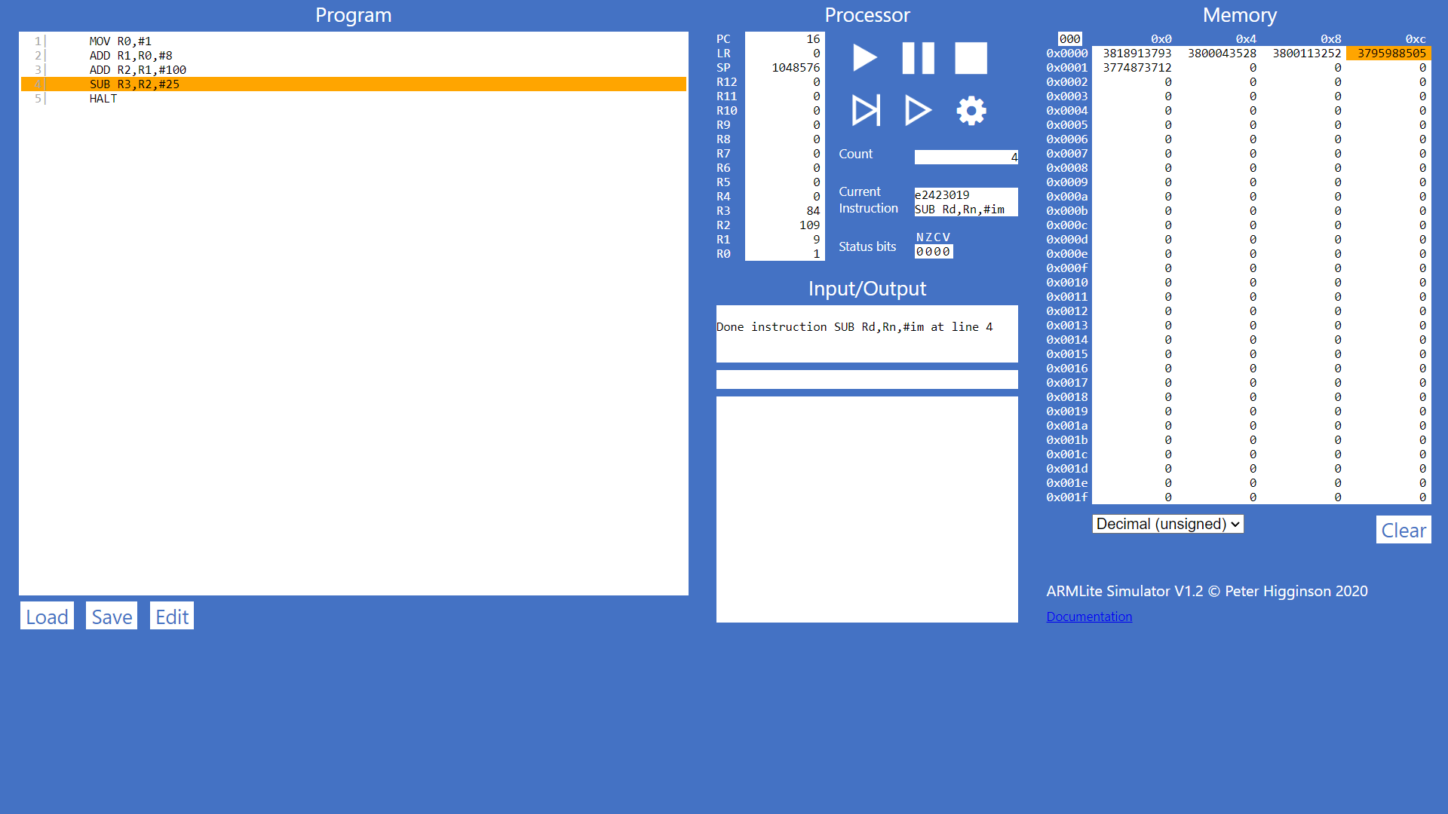
7.5.3 Task: Your 6 initial numbers are now 300, 21, 5, 64, 92, 18. Write an Assembly Program that uses these values to compute a final value of 294 (you need only use MOV, ADD and SUB). Place your final result in register R7 (don't forget the HALT instruction). When the program is complete, take a screen shot of the code and the register table.
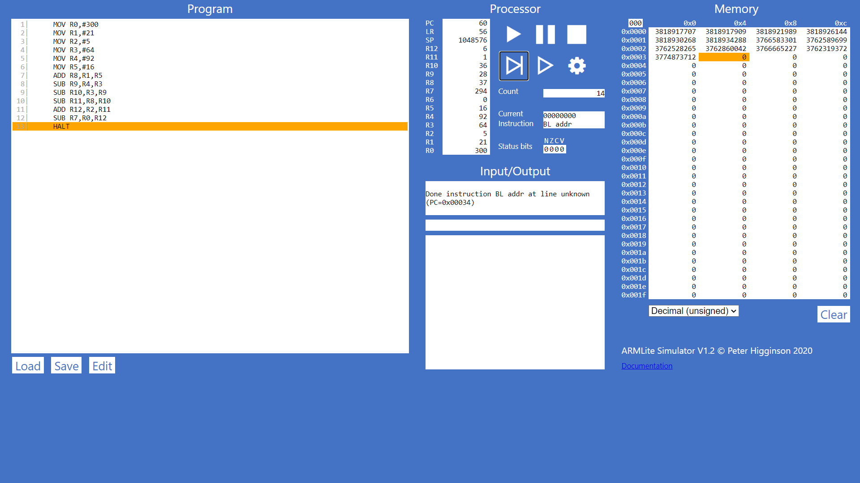
7.5.4 Task: Write your own simple program, that starts with a MOV (as in the previous example) followed by five instructions, using each of the five new instructions listed above, once only, but in any order you like – plus a HALT at the end, and with whatever immediate values you like. Enter your program into ARMlite, submit the code and when its ready to run, step through the program, completing the table below (make a copy of it in your submission document)
7.5.5 Lets play the game we played in 7.5.3, but this time you can use any of the instructions listed in this lab so far (ie,. MOV, AND, OR, and any of the bit-wise operators). Your six initial numbers are: 12, 11, 7, 5, 3, 2 and your target number is: 79. When the program is complete, take a screen shot of the code and the register table and paste into your submission document.
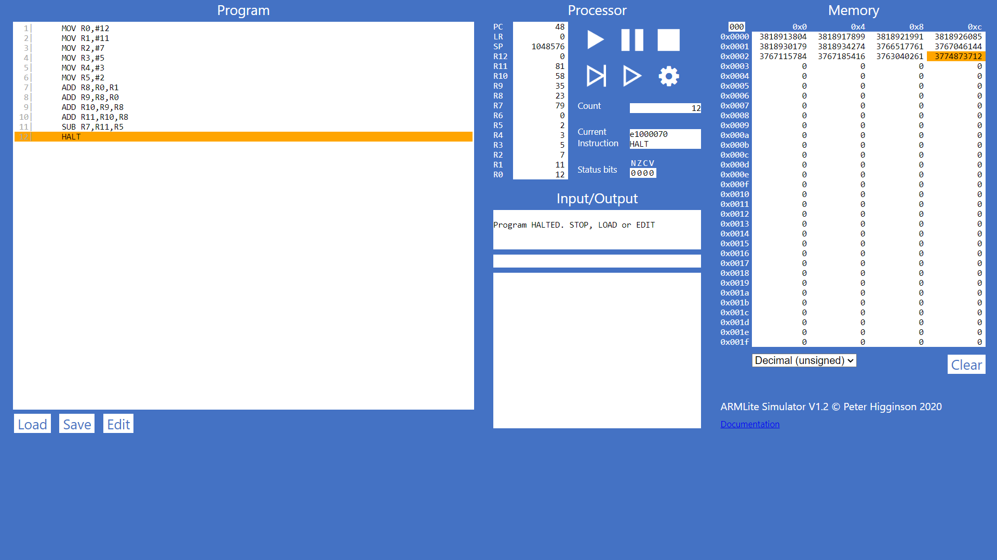
7.5.6 Let's play again! Your six initial numbers are: 99, 77, 33, 31, 14, 12 and your target number is: 32. When the program is complete, take a screen shot of the code and the register table and paste into your submission document.
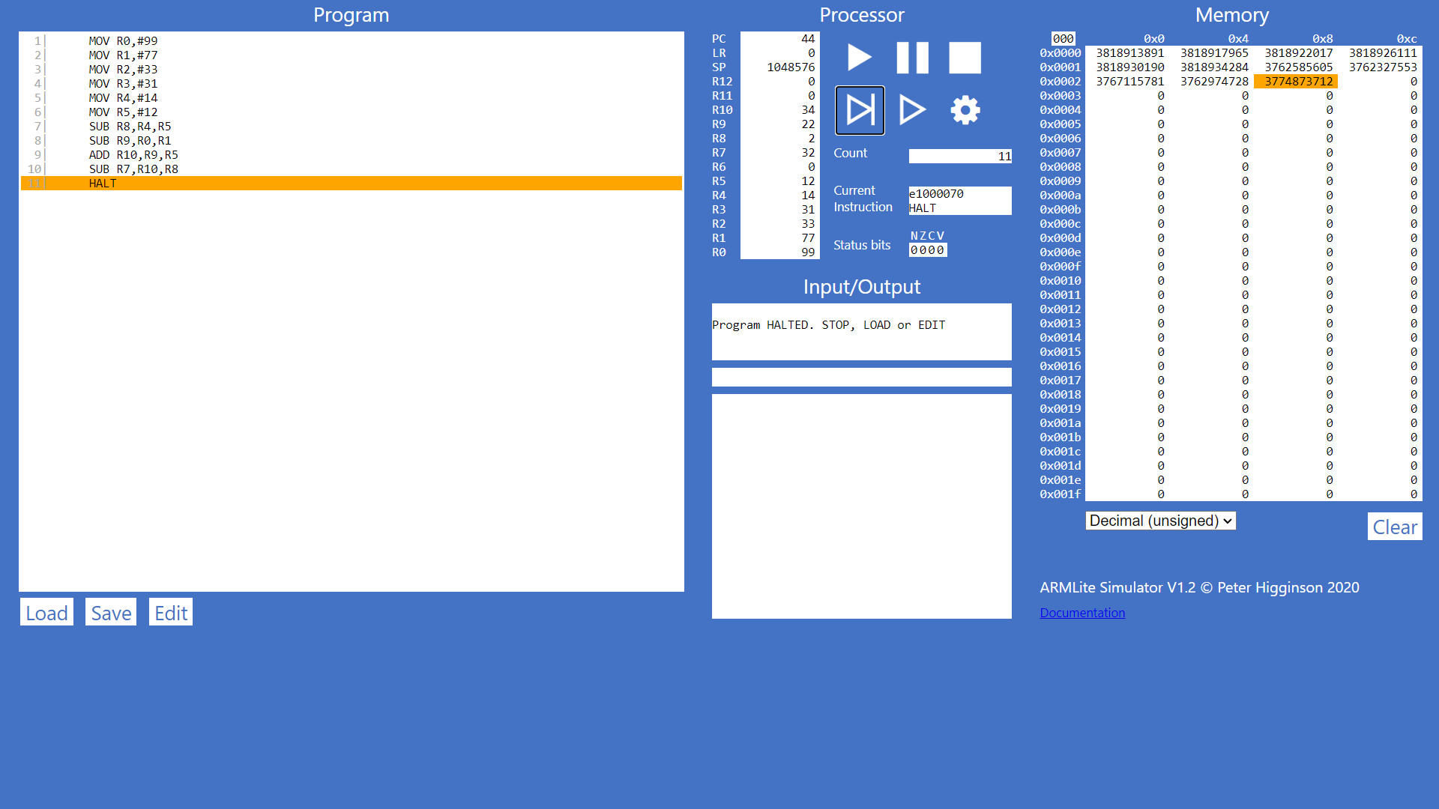
7.6.1 Why is the result shown in R1 a negative decimal number, and with no obvious relationship to 9999 ?
Because “LSL R1,R0,#18” command is to add 18 digits 0 in the end of R0 value (in binary form), and asign the value to R1, so R1 has the value that has no relationship to 9999 (which is 10011100001111 in binary)
7.6.3 What is the binary representation of each of these signed decimal numbers: 1, -1, 2, -2 What pattern do you notice ? Make a note of these in your submission document before reading on.
For 1: #1
For -1: #4294967295 (It’s 2³² – 1)
For 2: #2
For -2: #4294967294 (It’s 2³² – 2)
7.6.4 Write an ARM Assembly program that converts a positive decimal integer into its negative version. Start by moving the input value into R0, and leaving the result in R1. Take a screen shot showing your program and the registers after succesful execution, and paste into your submission document.
